Facts, Evidences, Statistical Reports, Opinions Dispute if Racial Profiling in Street-Level Crimes in America Exist
By: Andrea Santos
Norwalk Community College

Introduction
Racism is still visible and prominent in the country, particularly in communities. A current issue of it being present is Racial Profiling. It has been reported that some Law Enforcements stop drivers, motorists, pedestrians of certain types of racial or ethnical groups because they believe they are more likely to commit street-level crimes. Black or African Americans, Hispanics, Asians and Middle Easterners are said to be the ones dealing and experiencing this issue. These racial groups have been proclaimed searched, received countless tickets, warned, verbally assaulted and arrested by some Law Enforcements. Though, the Police argued that they don’t practice this. Racial Profiling has been constantly debated by many Human Rights Organizations, Activists, Lawyers and Police Officers if it really does exist or if people are just making a big deal out of it. Who is really to believe? Are there ways to be able to solve this issue? It has been also deliberated if how will a person know and consider as Racial Profiling? One way to address this matter first is by closely defining what Racial Profiling really is.
The Federal Government has stated and defined that Racial Profiling as unconstitutional, that this practice is “invidious,” “ineffective,” “wrong,” and “harmful to our rich and diverse democracy”. The evidence, facts, statistical reports, and opinions analyzed in this research report will firmly contemplate upon if Racial Profiling does exist in communities.

The Experts
Do Law Enforcements practice Racial Profiling in Street-Level Crimes in the country? This inquiry persists to be the main deliberation by the experts, and it is the question that convoys the research.
In “The Reality of Racial Profiling,” The Leadership Conference on Civil and Human Rights shows absolute statistical report evidences from the Department of Labor’s Bureau of Justice that proves the existence of Racial Profiling on the country’s highways. The year 2005 data resulted that Black and Hispanic Drivers and Motorists have larger percentage that is more likely to be arrested by the police compared to Whites. Further, a study from Arizona has similar results that supports this statistical data. The Arizona study proves that Racial Profiling is “counterproductive and a misallocation of scarce law enforcement resources”. Included in this report, an African-American Harvard Law Professor Charles Ogletree stated “If I'm dressed in a knit cap and hooded jacket, I'm probable cause” (Leadership Conference, 33).
Opposing experts have identical definitions and opinions of what Racial Profiling really is. Heather McDonald, author of Are Cops Racist? In her article “The Myth of Racial Profiling” he has two meanings to what Racial Profiling is. As McDonald explains, there is “hard” profiling which uses race as the only factor in assessing criminal suspiciousness and “soft” profiling is using race as one factor among others in gauging criminal suspiciousness: the highway police, for example, have intelligence that Jamaican drug posses with a fondness for Nissan Pathfinders transporting marijuana along the northeast corridor (McDonald, 1).
Likewise, the American Civil Liberties Union (ACLU) has a similar definition to Racial Profiling in “Racial Profiling Exists.” The organization explains, Racial Profiling as does not refer to the act of a law enforcement agent pursuing a suspect in which the specific description of the suspect includes race or ethnicity in combination with other identifying factors. Defining racial profiling as relying "solely" on the basis of race, ethnicity, national origin or religion can be problematic (ACLU, 1).

On the contrary, Police Officer, Frank Gale argues in his speech “The End of Racial Profiling is Highly Flawed and Should Not Be Passed” why Law Enforcements across America are opposing and against the passing of The End of Racial Profiling Act. He reasoned that Racial Profiling Act is nonsense and will result a big burden to the police’s workforce. Gale is totally against the passing of this act because he believes that Racial Profiling is not practiced by any Law Enforcement in the country. Moreover, Heather McDonald, editor to City Journal also agrees that Law Enforcements do not practice this because of little evidence.
“If I'm dressed in a knit cap and hooded jacket, I'm probable cause”.

While almost all the experts acknowledge that there is really Racial Profiling in communities the question still remains: Do Law Enforcements practice Racial Profiling in Street-Level Crime in the country? An action to start answering this inquiry is to interview a professional from this field about her insight and thoughts of Racial Profiling in Law Enforcement.
Methods
In order to answer my main research question--Do Law Enforcements practice Racial Profiling in Street-Level Crime in the country?—I interviewed Professor Althea E. Seaborn. She is a Professor and Program Coordinator for Criminal Justice at Norwalk Community College. This interview contains 7 questions total, both open-ended and closed questions (See Appendix A for a full list of interview questions).

The purpose of this study was to get credible information, opinion and experience from a professional who has knowledge of the topic. The interview was face-to-face and also through email. I used my phone to record our interview and wrote down notes.
Results
All throughout the interview, Criminal Justice Professor Seaborn agrees that Racial Profiling does exist in the country and with the Law Enforcement’s workforce. When challenged about the topic, almost all of her responses were positive and she agrees with the majority of the questions asked. When questioned about if the topic exists and is it evident today in communities her responses was “Yes”. When asked if statistical reports prove that the topic exists she agreed because it is based on legitimate stops of whom they track or who they don’t track. (See Figure 1 below).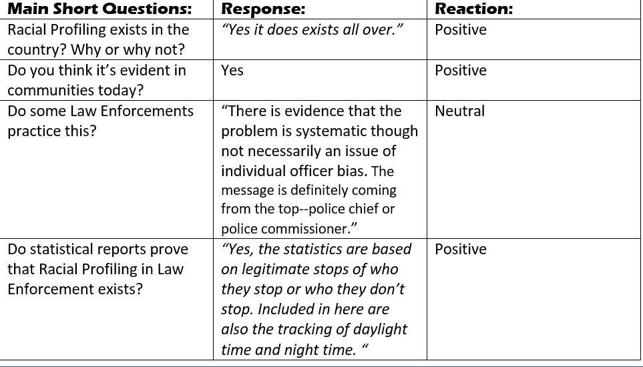Figure 1: Racial Profiling in Law Enforcement
When asked about the main question of the report—do Law Enforcements practice Racial Profiling, she had a neutral but a relevant answer to the research question. She said “If I believe that there is really Racial Profiling, I believe they made a decision to stop the race not because of some other reason. If they are looking for a suspect and he happens to be black, that’s not Racial Profiling that’s basically using race as a factor to help you solve a crime... I believe they made a decision it’s when you stop someone solely based on race that’s the deciding factor for why stop this person versus another person.”

When requested to answer if she had experienced being racially profiled, yes she had. Professor Seaborn briefly told what happened, how the officer asked her to pull over though she was not arrested because she showed her professional identification.

Lastly, when inquired if she has any knowledge or opinion about the End of Racial Profiling Act she briefly stated that she applaud all efforts to address the disparities within the criminal system which disproportionately affect people of color at every point in the criminal justice process.

Discussion
The results of this small study appear to confirm that Racial Profiling in Law Enforcement does exist in the country and in the police’s workforce. Although, the main outcome of the issue is how the expert legitimately define what Racial Profiling is in Street-Level Crimes and also how do one consider if it is really Racial Profiling. Because this interview efficiently got valid evidences, information and opinion, the results seem to suggest that it depends how the situation is; if Law Enforcements practice Racial Profiling. Possibly, one must first closely go back to the proper definition of Racial Profiling that was defined by the experts in order to know if a police officer is applying it.

Conclusion
The results from the interview conducted for this research uphold what most of the experts already know about the manifestation of Racial Profiling in police’s workforce. Further, they all have the same knowledge of the accurate and impartial definition of it and also how to distinguish an incident that is considered Racial Profiling. Most of them also agreed that statistical reports also prove Racial Profiling in Law Enforcement’s workforce.

With the facts and evidences provided and examined here, one can properly distinguish if someone is racially profiled rightly or either unsuitably depending on the situation.

Additionally, there is still two sided opinions and arguments whether or not police officers practice Racial Profiling. Organizations, legislators, lawyers, and police officers can continue their dispute about finding out if Racial Profiling in Law Enforcement’s workforce exists. The final decision will resolve whether Law Enforcements practice Racial Profiling fairly or unjustifiably.
References
American Civil Liberties Union. "Racial Profiling Exists." Racial Profiling. Ed. David Erik Nelson. Detroit: Greenhaven Press, 2009. Opposing Viewpoints. Rpt. from "Racial Profiling: Definition." www.aclu.org. 2005. Opposing Viewpoints in Context. Web. 22 Oct. 2015.
Gale, Frank. "The End Racial Profiling Act Is Highly Flawed and Should Not Be Passed." Racial Profiling. Ed. Carol Ullmann and Lynn M. Zott. Detroit: Greenhaven Press, 2013. Opposing Viewpoints. Rpt. from "Testimony of Frank Gale, National Second Vice President, Grand Lodge, Fraternal Order of Police, on 'Ending Racial Profiling in the United States,'." 2012. Opposing Viewpoints in Context. Web. 8 Oct. 2015.
The Leadership Conference on Civil and Human Rights “The Reality of Racial Profiling”. Racial Profiling. The Leadership Conference on Civil and Human Rights/The Leadership Conference Education Fund, March 2011. Web. 8 Oct 2015.
MacDonald, Heather. "The Myth of Racial Profiling." City Journal. Ed. James D. Torr. San Diego: Greenhaven Press, 2004. Web. 8 Oct. 2015.
Seaborn, Althea. Personal Interview. 20 Oct 2015.

Appendix A
Interview Questions for Professor Seaborn

What are your thoughts about Racial Profiling in Law Enforcement? Do you think it exists in the country? Why or why not?

Do you think Racial Profiling in Law Enforcement is still evident in communities today?

What ethnicity/race do you know that experience Racial Profiling in Law Enforcement? Why do you think they are discriminated by that?

Have you heard of any stories, news or reports about Racial Profiling? What do you think about it, do Law Enforcements really racial profile citizens like Blacks, Latinos, Asians or middle easterners or it is just overreacting said by some people.

Have you seen, experienced or think you have experienced Racial Profiling? Kindly share if you did? Do you think that was really Racial Profiling? Why or why not?

Do you have any knowledge or heard of the End of Racial Profiling Act? Would you please share if you have any? If you do, do you think the End of Racial Profiling Act should be passed why or why not?
- Do you believe Law Enforcements practice Racial Profiling?

